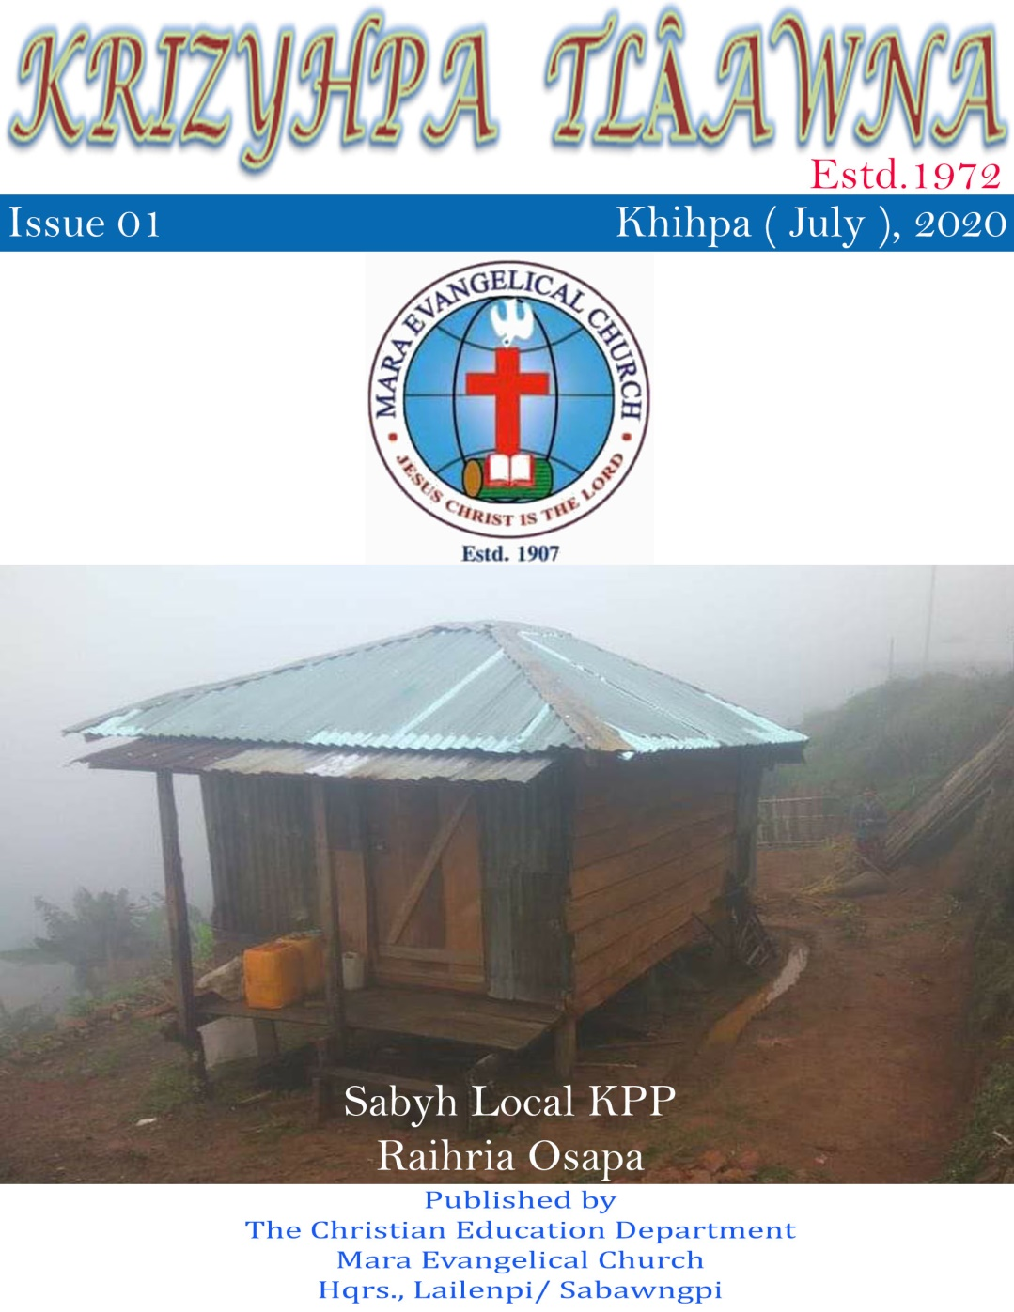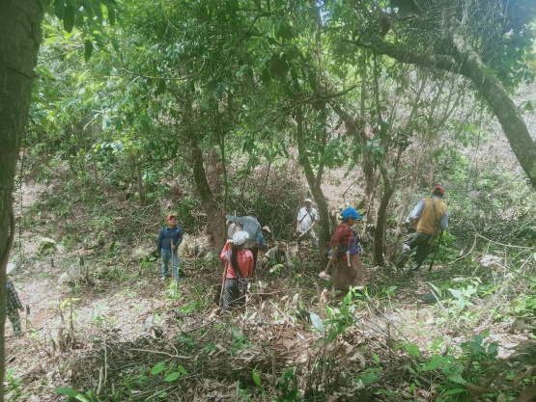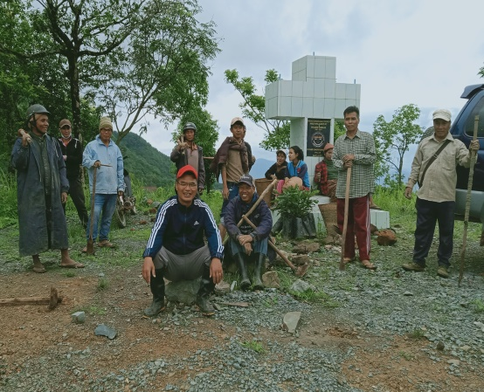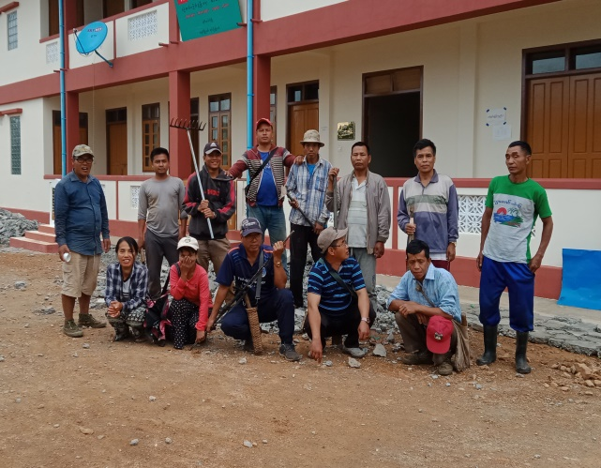­­

**Awnanopa Hmasiena nata Akaona vâta MEC Assembly Hriatuhzy Aly nata Thathao kawpa ta Chicheina achâ**